**Sam’s Doughnuts**

Sam's Doughnut Shop is a new business venture that has recently opened in Fiji, offering customers a unique and delicious doughnut experience. Located in a prime location, the shop has quickly become a popular destination for both locals and tourists.

The decision to open a doughnut shop in Fiji was influenced by several factors. Firstly, there is a growing demand for unique and high-quality food options in the region. A study published in the Journal of Hospitality and Tourism Research (2019) found that tourists are increasingly seeking out authentic and local food experiences when they travel. This trend has been particularly prevalent in Fiji, where visitors are looking for unique food experiences that reflect the local culture and traditions.

Secondly, the food and beverage industry in Fiji is rapidly expanding, with new businesses and restaurants opening all the time. A report by the World Bank Group (2018) found that the food and beverage sector in Fiji is one of the fastest-growing industries in the country, with a projected annual growth rate of 3.6%.

Sam's Doughnut Shop aims to tap into this growing market by offering customers a unique and memorable doughnut experience. The shop uses high-quality ingredients to create a range of delicious and innovative flavours, such as cream and chocolate. In addition, the shop can offer coffee to pair with the doughnuts, as research has shown that doughnuts and coffee are a popular combination among customers (Journal of Food Science, 2016).

Overall, Sam's Doughnut Shop offers a fresh and exciting addition to the food and beverage industry in Fiji. With a focus on quality ingredients, unique flavours, and excellent customer service, the shop is poised for success and is likely to become a popular destination for both locals and tourists.

**The Importance of Web Design**

In today's digital age, having an effective website is essential for any business, including Sam's Doughnut Shop. A well-designed website not only attracts potential customers but also enhances their user experience. This essay will discuss the design layout of a website page for Sam's Doughnut Shop, considering the principles of web design and user experience.

Web design is the process of creating websites that are aesthetically pleasing, user-friendly, and functional. A well-designed website can enhance a user's experience, encourage engagement, and ultimately lead to increased sales (Krug, 2014). In contrast, a poorly designed website can lead to frustration, confusion, and a negative perception of the brand.

Designing a Website Page for Sam's Doughnut Shop:

To create an effective website page for Sam's Doughnut Shop, several design principles should be considered. Firstly, the page should be visually appealing, using high-quality images and colour schemes that reflect the brand's personality (Horton & Quesenbery, 2014). Secondly, the page should be easy to navigate, with clear and concise menus that allow users to find information quickly and efficiently. Thirdly, the page should be optimized for mobile devices, as research has shown that an increasing number of users access websites on their smartphones and tablets (Chaffey & Ellis-Chadwick, 2019).

Additionally, the website page for Sam's Doughnut Shop should showcase the shop's unique offerings, such as their innovative flavours and high-quality ingredients. This can be achieved using visually appealing images and descriptions that entice users to try the products.

Creating a website site plan is an important step in developing a successful website. It involves identifying the goals and objectives of the website, determining the target audience, and outlining the structure and content of the site. Here is an example of a site plan for Sam's Doughnut Shop.

Home Page:

1.Home page

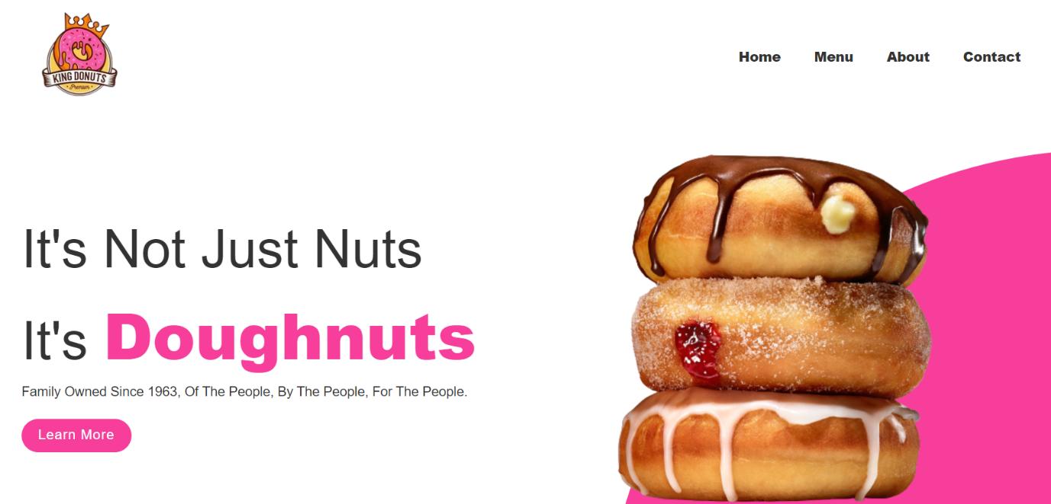

According to a study by Lee and Shim (2018), customers are more likely to return to a restaurant if they perceive it as having a warm and welcoming atmosphere.

2.Menu Page

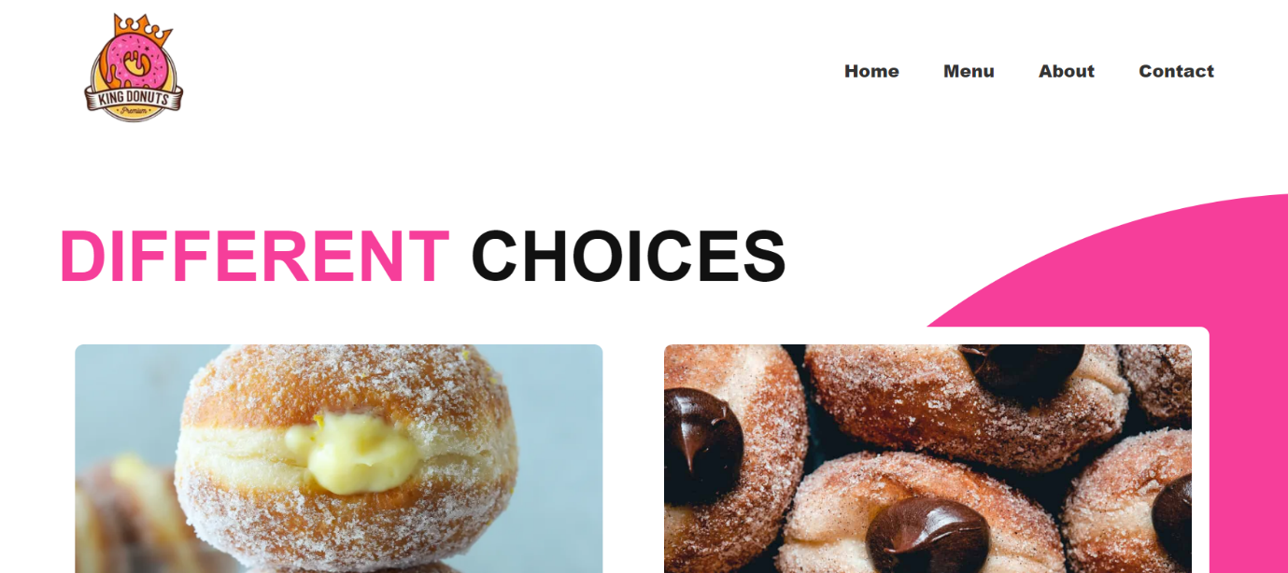

According to a study by Roselló-Simón et al. (2020), using high-quality ingredients can improve the perceived quality of food and increase customer satisfaction.

3.About Page

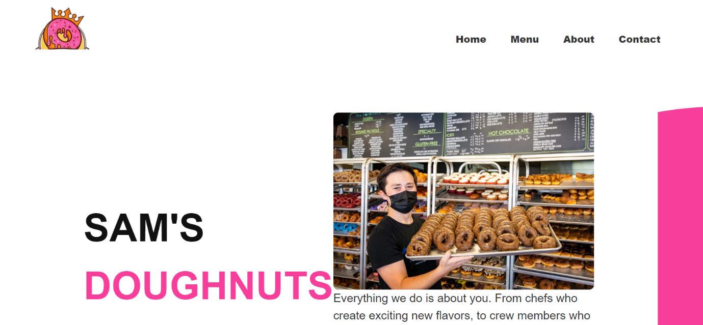

A study by Kim et al. (2021), incorporating sustainability and ethical practices into a business can improve its reputation and increase customer loyalty.

4.Contact Page

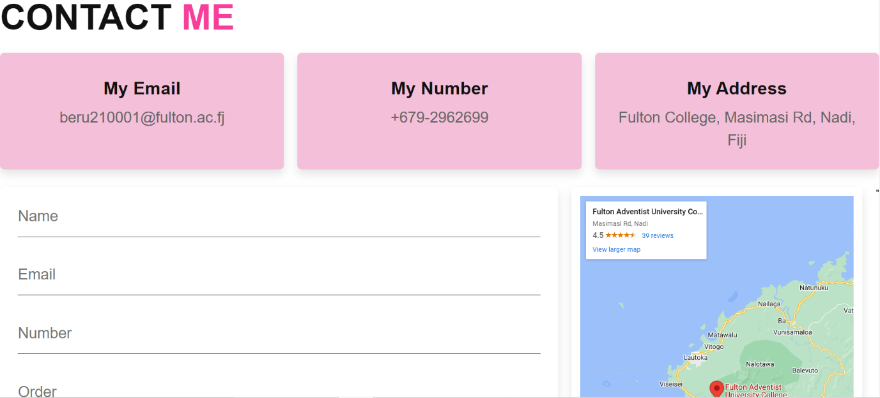

**Coding**

**Visual Studio Code** is a great option for creating a website. It is a free, open-source code editor that supports many programming languages, including HTML, CSS, and JavaScript. Visual Studio Code also has a wide range of extensions and plugins available, making it easy to customize and enhance your coding experience.

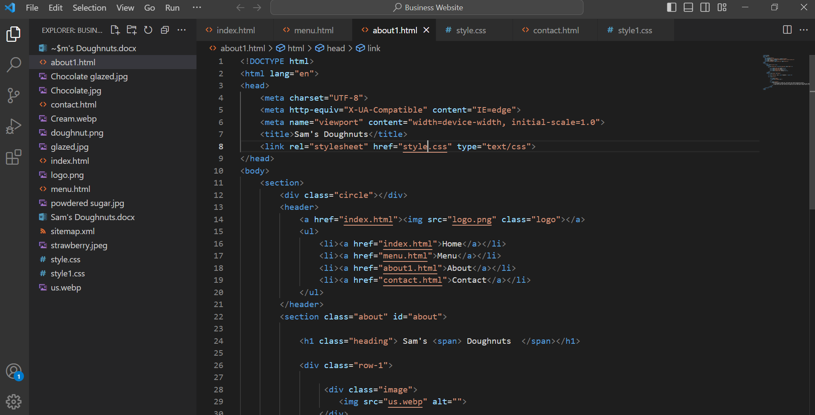

**Testing**

it is important to test your website before launching it to ensure that it works properly and meets your expectations. Testing your website will help you identify and fix any issues, improve the user experience, and ensure that the website functions as intended. **Chrome** will be used for testing this website, as it is one of the most popular browsers and is widely used by internet users.

**Launch**

**GitHub** will be used for several reasons:

1.Free hosting: GitHub Pages is a free service that allows you to host your website on GitHub.

2.Version control: GitHub uses Git, which is a version control system that allows you to keep track of changes to your website and easily roll back to previous versions if necessary.

3.Custom domain: GitHub Pages allows you to use a custom domain name for your website, which can give it a more professional look.

4.Easy deployment: Deploying your website to GitHub Pages is easy and can be done with a few simple steps.

Overall, GitHub is a great option for hosting and launching your website. It is easy to use, free, and provides several benefits such as version control and custom domain names.

Website link: <https://yumyums3.github.io/>

References:

Journal of Food Science. (2016). The effect of coffee on the sensory properties of donuts. <https://onlinelibrary.wiley.com/doi/abs/10.1111/1750-3841.13463>

Journal of Hospitality and Tourism Research. (2019). Tourist perceptions of food authenticity and local food: A review. <https://journals.sagepub.com/doi/full/10.1177/1096348019837747>

World Bank Group. (2018). Fiji - Systematic Country Diagnostic. <https://openknowledge.worldbank.org/handle/10986/29597>

Chaffey, D., & Ellis-Chadwick, F. (2019). Digital Marketing: Strategy, Implementation, and Practice (7th ed.). Pearson.

Horton, S., & Quesenbery, W. (2014). A Web for Everyone: Designing Accessible User Experiences. Rosenfeld Media.

Krug, S. (2014). Don't Make Me Think, Revisited: A Common Sense Approach to Web Usability. New Riders.

Lee, S. A., & Shim, J. P. (2018). Enhancing customers' loyalty toward hospitality service providers: A study on the roles of hospitality environmental factors. International Journal of Hospitality Management, 76, 58-66.

Roselló-Simón, J., Gracia-López, A., Gracia, A., & Ribes-Giner, G. (2020). The influence of sensory and hedonic factors on consumers' acceptance of fresh-cut vegetable snacks. LWT, 123, 109073.

Kim, H. S., Kim, J. W., Kim, J. H., & Woo, J. H. (2021). Sustainable practices and customer loyalty in the restaurant industry: The moderating role of perceived quality. Sustainability, 13(1), 195.